- Open BD FACSDiva Software

- Choose your PI’s last name to login. Capital Initials are the password as provided during training.
- After cleaning the instrument as described in the instructions click on the “+” sign on the left side of “Shared View” to open the QC folder.
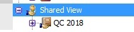
- Double click on the brown notebook which represents the Experiment under “QC”.
- Click on the “+” on the left of the current month Specimen.
- There are 2 ways to add a “New Tube” .
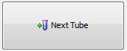
  - Choose the last tube and click “Next Tube” on the acquisition dashboard..
  - Click on the icon on the top showing a Tube and a star in the corner.

- Make sure the arrow to the left of the new tube is active and highlighted green in order to analyze the sample in the main acquisition dashboard.
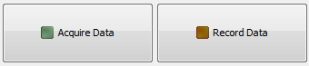
- Don’t forget to record the data. The Recording button is located to the right of the “Acquire Data” button.
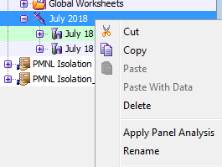
- Record 2000 events and rename the Tube to current date (the options pictured below show up when you right click on the tube you wish to edit.

