In order to analyze your samples please follow the instructions:
- Find a folder with your name.
User
- Click a “+” sign to open the Folder 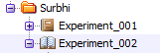
- Double click on the Experiment of interest to open it.
- Add a New Specimen and rename it with today’s date.
- Add New Tubes that correspond to your samples. 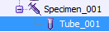
- In order to start analyzing samples make sure to click the arrow to highlight it green.
- Press Acquire Data then Record Data in order to start recording your samples.
1.
2.
- When you are finished analyzing your samples, make sure to save your data outside the software.
- Right click on the Specimen you created today that contains all of your samples .
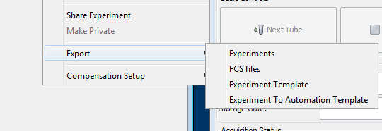
- Choose option “Export”
- Then choose “FCS Files”
1.
- Choose a directory like a Desktop or your Flash Drive to save your files.
- Make sure you exit out of the software before you shut down or log off the Windows.

- If you need a pdf file of all the samples from that day:
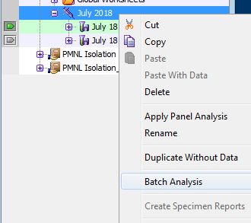
  - Click on the first sample then click on the specimen (the sample will be highlighted green and the specimen will be blue.
  - Right click the specimen and choose “Batch Analysis”

  - Once the Menu opens up, choose appropriate options as shown
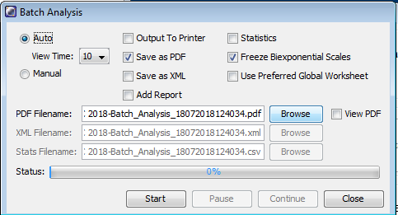
  - Click Browse to save the file in the location of your choice.
  - Hit Start. If the “View Time” option is chosen, that is at least how long each file will be presented to you before another is appended.
- Make sure you exit out of the software before you shut down or log off the Windows.

