Training:
- Theory:
Learn about the principles of flow cytometry: https://www.youtube.com/watch?v=sfWWxFBltpQ&t=1s
Explore data analysis for flow cytometry: https://www.youtube.com/watch?v=ccR5snuCE80&t=1s
Training will happen in person. In the shared folder "Training files"( https://drive.google.com/drive/folders/1WT81s0XCsnBQswGq5FSR2YLDrGd7Xv-6?usp=share_link ) are files that are helpful if watched before the training. The movie Media1_8 will help you to learn how to login into instrument, start, clean, and shut it down. You will follow instruction from the movie during first part of training. We strongly suggest that you watch "Experimental Setup in DIVA (from 33:30 to 1:14:00). It will make you familiar with BD Diva software operating BD instruments. During training we will do very similar operation using software to control instrument and data acquiring. For reviewing software, please look at the file entitled D_PPP Tutorial BD FACSDiva Software.
- Practical part:
Prepare your samples so that the final concentration of cells is 1*10^6 cells/mL per sample. The minimum volume necessary for analysis is 300 μL. Please make sure your samples are filtered right before the training as any samples that are found to have aggregates will NOT be analyzed on our instruments. Do not forget to bring the controls to properly analyze your samples and setup gates. Unstained and/or untreated, single stains (for compensations), and FMOs (for gating strategy) if you are using?
If you or your lab member performed similar experiments, or you have a published paper following an existing protocol, please send a pdf document showing the details of analysis strategy you wish to accomplish.
Instructions for accessing the FCS Express flow cytometry analysis software to analyse your raw flow data.
- FCS Express 6.0 (network license):
The DeNovo FCS Express on-line program is only accessible on a Windows operating system linked to a University network.
- Click on the Windows icon in lower left corner
- In search field write: \\fcs.biotech.illinois.edu
- Username: uofi\Your NetID
- Password: Your AD Password
- Navigate to one of the folders (we have 3 different versions available)
- Copy the “FCS Express- Shortcut” to your Desktop
- Double click on the icon
-If prompted click 'Run' to start the program

If the program says, too many users logged in, find the file extension “FELogin” and if you a person has been logged in for more than a day, please send an email to marwoz@illinois.edu or kjans01@illinois.edu, so that we can delete the user to give another person access.
*** When the 'User Selection' box appears create a 'New User' (or select one that you have previously created). NEVER USE DEFAULT. Please let me know if you experience any issues logging in or would like any help analyzing your data with the program. There are useful tutorials and webinars available on the DeNovo website as well.

If you receive the following message while attempting to log in to FCS Express:
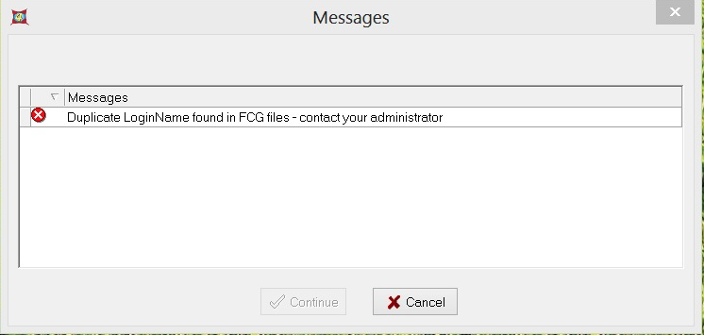
The problem is that within the C Drive -> De Novo Software ->FCS Express 4 Flow Research Edition folder, there are multiple FCG files whose names begin with the word ‘Default’:
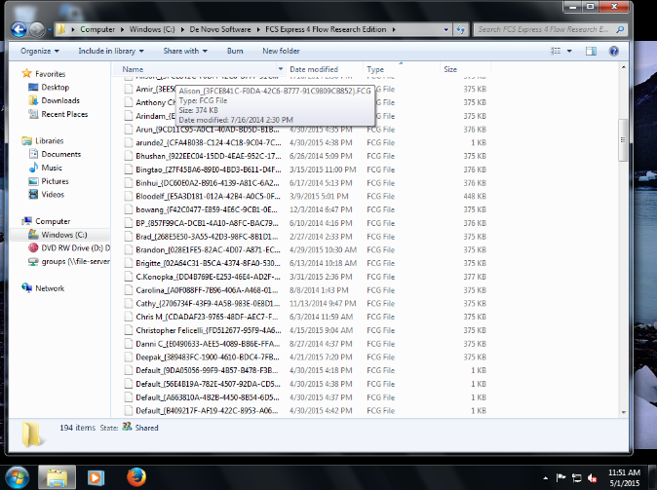

This is what FCS Express means when it reports "Duplicate LoginName found in FCG files".

It is reporting that there are several people who are using the software by logging in as the Default user, rather than their names.

The original Default file will also be the oldest one. A normal sized FCG file is 500 KB. We must delete all the 1 KB FCG files from that folder that start with Default (keep only the oldest one).
- FCS Express 7.0
You can also explore the FCS Express 7.0 - download a demo for 30 days and run in your computer (https://denovosoftware.com/demo-overview/). Afterwards, if you wish to continue using FCS express v 7.0 you can send an email to to marwoz@illinois.edu or kjans01@illinois.edu and we will activate your email id to use beyond the 30-day period (please provide us with the email address you have used to create account on Denovo website). However, to use the CMtO dongle license you will need to first uninstall the demo version and then download and install the program again.
We have three FCS express 7.0 licenses activated and at once no more than 3 people can use it. There is 1h limit automatically set to log you out-hence please save the data frequently. FCS express 7.0 runs on both on Win and Mac platforms.
FCS Express has both long and short video tutorials/webinars online in their channel. Both the program and video tutorial links are here. It is best you subscribe to the Channel for the best experience.
- Video Tutorials
https://www.youtube.com/DeNovoSoftware
- What is new in FCS Express 7.0
https://www.youtube.com/watch?v=tCoWPF7un18
- Upcoming Webinars
https://denovosoftware.com/videos/upcoming-webinars/
Additional information and links.
- BD FACS Diva software
https://docs.google.com/presentation/d/1MQIGz6dgo_31gOEjeq5uzJqzOwveWt8mgh49dC6-Nqw/edit#slide=id.p1
- Practical Flow Tutorial.wmv
https://drive.google.com/drive/u/1/folders/1WT81s0XCsnBQswGq5FSR2YLDrGd7Xv-6
- Cytometry workflow:
https://docs.google.com/presentation/d/1Ht2FbPpj4OkbjM8mj6R_ZVjrDwIgQzeuccRSzy3Mq3c/edit#slide=id.p1
- D_PPP Tutorial BD FACSDiva Software June_5 2020
https://docs.google.com/presentation/d/1MQIGz6dgo_31gOEjeq5uzJqzOwveWt8mgh49dC6-Nqw/edit - slide=id.p1
- Experimental Setup in DIVA
For Setting Experiment on DIVA (flow cytometry software for acquiring data from LSRII and Fortessa instruments) please watch this video (from 33:30 up to 1:14:00)
https://www.youtube.com/watch?v=pMd-8RSKkHE&feature=youtu.be

